Meerut Institute of Engineering and Technology, Meerut

**Department of Computer Science & Engineering**

**Project Expo. Celebration (04-04-2025)**

## (B.Tech Final Year)

## Session: 2024-2025

1. **Name of Project: “ Enhanced Real-Time Traffic Sign Recognition System with Multilingual Captions and Voice Alerts”**

## **Student Names:** 1. Harsh Pal 2. Krishna Parashar 3. Azeem Hussain

1. **Guide Name:** Dr. Satendra Kumar

# Abstract: 5. Objective:

* 1. Real-time traffic sign recognition system., surpassing 1. Analyze and Develop an accurate recoginiton model. traditional methods. 2. Implement multilingual and voice support.
  2. Multilingual captions with voice alerts. 3. Implement Ensure real-time system performance.
  3. Enhances road safety using AI.

# Flow chart/ Block diagram: 7. Technology Used:

* 1. CNN

OCR & Lang. Detection

Traffic Sign Detection

Input Video Stream

Start

* 1. Pytorch
  2. TTS

Output Video frame with alert

Caption and alert generation

Translation

# Applications: 9. Photographs (with Project & Research Paper):

* 1. 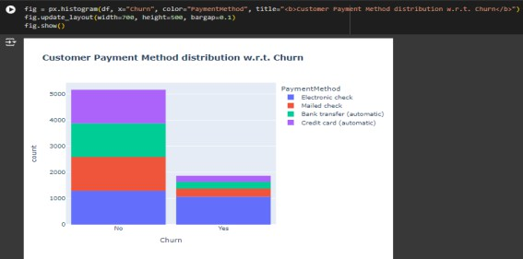Customer Retention Strategies
  2. Marketing Campaign Optimization
  3. Product and Service Development

# References:

1. Redmon, J., & Farhadi, A. (2018). YOLOv3: An Incremental Improvement.
2. Stallkamp, J., et al. (2012). The German Traffic Sign Recognition Benchmark: A Multi-Class Classification Competition.
3. Goodfellow, I., et al. (2016). Deep Learning. MIT Press.